Nondegenerate Conic

Definition
# Source: AI Source: Provided by: [Data Path: Persons Table -> ID Column: 1, Name_En Column: Motasem Essam] -> From: [ChatGPT] on [7/25/2026]
A Nondegenerate Conic is a conic that represents a genuine conic curve rather than a degenerate form such as a point, a straight line, or a pair of straight lines.
In ordinary Euclidean geometry, the three main types of nondegenerate conics are the ellipse, parabola, and hyperbola. A circle is a special type of ellipse.
Nondegenerate conics are studied in Analytic Geometry, Conic Sections, and Projective Geometry.

Simple Definition
# Source: AI Source: Provided by: [Data Path: Persons Table -> ID Column: 1, Name_En Column: Motasem Essam] -> From: [ChatGPT] on [7/25/2026]
A nondegenerate conic is a genuine conic curve that does not collapse into simpler geometric objects such as points or straight lines.

Main Types of Nondegenerate Conics

1. Ellipse
# Source: AI Source: Provided by: [Data Path: Persons Table -> ID Column: 1, Name_En Column: Motasem Essam] -> From: [ChatGPT] on [7/25/2026]
A closed curve in which the sum of the distances from any point on the curve to two fixed points, called the foci, is constant.
Standard equation:
$$\frac{x^{2}}{a^{2}}+\frac{y^{2}}{b^{2}}=1$$
Example: $\frac{x^{2}}{9}+\frac{y^{2}}{4}=1$.
A circle occurs when $a=b$.
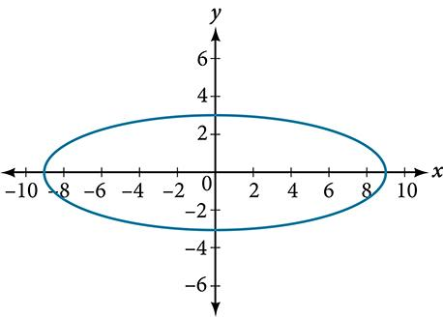

2. Parabola
# Source: AI Source: Provided by: [Data Path: Persons Table -> ID Column: 1, Name_En Column: Motasem Essam] -> From: [ChatGPT] on [7/25/2026]
An open curve whose points are equidistant from a fixed point, called the focus, and a fixed line, called the directrix.
Standard equation:
$$y^{2}=4px$$
Example: $y^{2}=8x$.
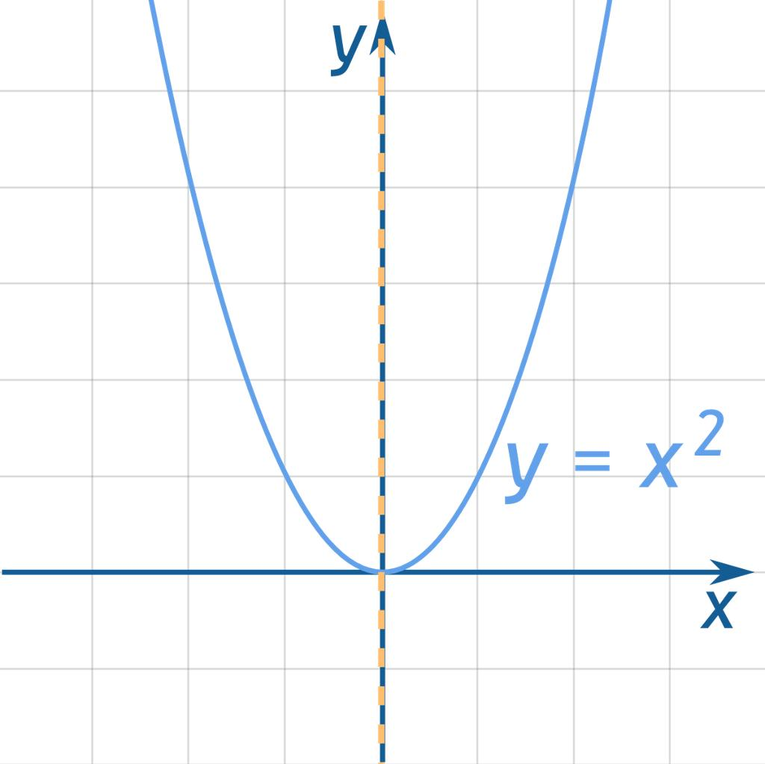

3. Hyperbola
# Source: AI Source: Provided by: [Data Path: Persons Table -> ID Column: 1, Name_En Column: Motasem Essam] -> From: [ChatGPT] on [7/25/2026]
A curve consisting of two separate branches, for which the absolute difference between the distances to two fixed foci is constant.
Standard equation:
$$\frac{x^{2}}{a^{2}}-\frac{y^{2}}{b^{2}}=1$$
Example: $\frac{x^{2}}{9}-\frac{y^{2}}{4}=1$.
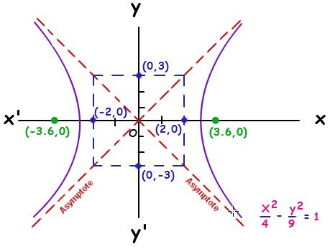

General Equation of a Nondegenerate Conic
# Source: AI Source: Provided by: [Data Path: Persons Table -> ID Column: 1, Name_En Column: Motasem Essam] -> From: [ChatGPT] on [7/25/2026]
A conic in the Cartesian plane can be represented by the general second-degree equation:
$$Ax^{2}+Bxy+Cy^{2}+Dx+Ey+F=0$$
where $A,B,C$are not all zero.
To test whether the conic is nondegenerate, form the matrix:
$$M=\left(\begin{matrix}A & B/2 & D/2 \\ B/2 & C & E/2 \\ D/2 & E/2 & F\end{matrix}\right)$$
For a projective conic:
$$\boxed{det⁡\left(M\right)≠0}$$
means the conic is nondegenerate, while $det⁡\left(M\right)=0$means it is degenerate.
The quadratic discriminant
$$Δ=B^{2}-4AC$$
helps classify the conic's type:
- $Δ<0$: ellipse-type.
- $Δ=0$: parabola-type.
- $Δ>0$: hyperbola-type.
These discriminant rules classify the quadratic part; the full equation must still be checked to determine whether the conic is nondegenerate and has real points.

Examples
# Source: AI Source: Provided by: [Data Path: Persons Table -> ID Column: 1, Name_En Column: Motasem Essam] -> From: [ChatGPT] on [7/25/2026]
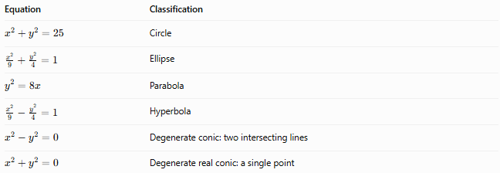
Equation | Classification

$$x^{2}+y^{2}=25$$ | Circle

$$\frac{x^{2}}{9}+\frac{y^{2}}{4}=1$$ | Ellipse

$$y^{2}=8x$$ | Parabola

$$\frac{x^{2}}{9}-\frac{y^{2}}{4}=1$$ | Hyperbola

$$x^{2}-y^{2}=0$$ | Degenerate conic: two intersecting lines

$$x^{2}+y^{2}=0$$ | Degenerate real conic: a single point

Nondegenerate Conic vs. Degenerate Conic
# Source: AI Source: Provided by: [Data Path: Persons Table -> ID Column: 1, Name_En Column: Motasem Essam] -> From: [ChatGPT] on [7/25/2026]
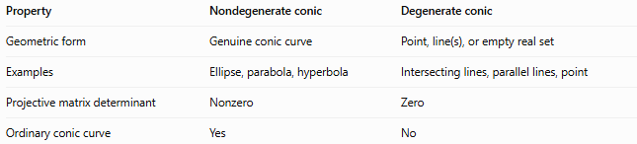
Property | Nondegenerate conic | Degenerate conic
Geometric form | Genuine conic curve | Point, line(s), or empty real set
Examples | Ellipse, parabola, hyperbola | Intersecting lines, parallel lines, point
Projective matrix determinant | Nonzero | Zero
Ordinary conic curve | Yes | No

Classification Summary
# Source: AI Source: Provided by: [Data Path: Persons Table -> ID Column: 1, Name_En Column: Motasem Essam] -> From: [ChatGPT] on [7/25/2026]
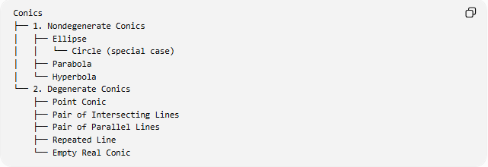
Conics
├── 1. Nondegenerate Conics
│ ├── Ellipse
│ │ └── Circle (special case)
│ ├── Parabola
│ └── Hyperbola
└── 2. Degenerate Conics
├── Point Conic
├── Pair of Intersecting Lines
├── Pair of Parallel Lines
├── Repeated Line
└── Empty Real Conic

Key Points
# Source: AI Source: Provided by: [Data Path: Persons Table -> ID Column: 1, Name_En Column: Motasem Essam] -> From: [ChatGPT] on [7/25/2026]
- A nondegenerate conic is a genuine conic rather than a collapsed geometric form.
- The three principal types are the ellipse, parabola, and hyperbola.
- A circle is a special case of an ellipse.
- The determinant of the full conic matrix provides a standard algebraic test for degeneracy.
- A nondegenerate projective conic can still have no real points in the real affine plane, depending on the equation and coordinate setting.

Conclusion
# Source: AI Source: Provided by: [Data Path: Persons Table -> ID Column: 1, Name_En Column: Motasem Essam] -> From: [ChatGPT] on [7/25/2026]
A Nondegenerate Conic is a genuine conic represented by a nondegenerate second-degree equation. Its principal types are the ellipse, parabola, and hyperbola, with the circle included as a special ellipse. Its opposite classification is the Degenerate Conic, which represents a collapsed form such as a point or a collection of lines.

